ID SUPER | FOTO | ITEM | COL | Quantity total | 35 | 36 | 37 | 38 | 39 | 40 | 41 | RRP | Sum RRP
151154 |  | TATA ITALIA 351 1608-L1 | WINE | 162 | 0 | 30 | 33 | 54 | 25 | 11 | 9 | 39,95 € | 6.471,90 €
150667 | 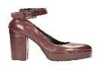 | TATA ITALIA 355 S21735-E03 | DK WINE | 155 | 8 | 15 | 26 | 41 | 34 | 21 | 10 | 49,95 € | 7.742,25 €
150009 |  | TATA ITALIA 130 9379A-1 | RED | 139 | 10 | 19 | 24 | 31 | 21 | 19 | 15 | 49,95 € | 6.943,05 €
149935 | 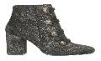 | TATA ITALIA 313 DW526-18 | GOLD | 134 | 8 | 15 | 46 | 37 | 9 | 12 | 7 | 55,95 € | 7.497,30 €
151155 | 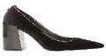 | TATA ITALIA 351 1608-L1 | BLACK | 133 | 0 | 25 | 27 | 54 | 16 | 7 | 4 | 39,95 € | 5.313,35 €
150910 | 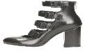 | TATA ITALIA 355 X21709-X11-4 | BLACK | 130 | 10 | 19 | 34 | 39 | 11 | 15 | 2 | 59,95 € | 7.793,50 €
150008 | 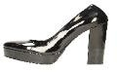 | TATA ITALIA 130 9379A-1-P | BLACK | 129 | 0 | 16 | 34 | 48 | 15 | 12 | 4 | 49,95 € | 6.443,55 €
150011 | 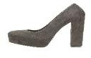 | TATA ITALIA 130 9379A-1-M | BLACK | 127 | 5 | 19 | 22 | 46 | 15 | 18 | 2 | 49,95 € | 6.343,65 €
149925 | 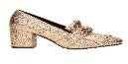 | TATA ITALIA 313 DW525-31 | ROSE GOLD | 116 | 8 | 19 | 30 | 36 | 8 | 13 | 2 | 45,95 € | 5.330,20 €
150039 | 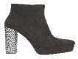 | TATA ITALIA 130 9379B-1 | BLACK | 114 | 10 | 15 | 18 | 38 | 11 | 19 | 3 | 59,95 € | 6.834,30 €
150652 | 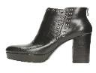 | TATA ITALIA 355 X21737B-Y01-4 | BLACK | 110 | 7 | 13 | 13 | 31 | 23 | 20 | 3 | 59,95 € | 6.594,50 €
150665 | 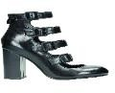 | TATA ITALIA 355 X21735A-L04-4 | BLACK | 109 | 10 | 11 | 30 | 25 | 11 | 11 | 11 | 55,95 € | 6.098,55 €
149104 |  | TATA 334 9255-1 | PINK | 108 | 2 | 12 | 11 | 39 | 17 | 21 | 6 | 49,95 € | 5.394,60 €
149108 | 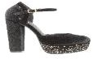 | TATA 334 B0821-2 | BLACK | 107 | 2 | 8 | 17 | 34 | 17 | 21 | 8 | 49,95 € | 5.344,65 €
150651 | 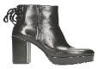 | TATA ITALIA 355 X21737A-E07-5 | BLACK | 105 | 3 | 7 | 19 | 30 | 21 | 20 | 5 | 59,95 € | 6.294,75 €
149970 | 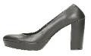 | TATA 48 LP90885-186- P | BLACK | 100 | 2 | 9 | 14 | 31 | 21 | 20 | 3 | 55,95 € | 5.595,00 €
149082 | 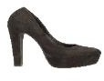 | TATA 334 1251-1 | BLACK | 97 | 7 | 6 | 21 | 40 | 8 | 15 | 0 | 49,95 € | 4.845,15 €
149082
149104
149108
149970
150009
150011
150008
150039
149925
149935
151155
151154
150667
150910
150665
150651
150652

ID SUPER | FOTO | ITEM | COL | Quantity total | 35 | 36 | 37 | 38 | 39 | 40 | 41 | RRP | Sum RRP
149972 |  | TATA 48 LP90885-186 | WINE | 97 | 3 | 13 | 16 | 28 | 19 | 12 | 6 | 55,95 € | 5.427,15 €
150921 | 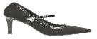 | TATA ITALIA 130 9207A-22 | BLACK | 96 | 5 | 9 | 24 | 31 | 12 | 11 | 4 | 39,95 € | 3.835,20 €
150650 | 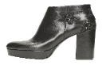 | TATA ITALIA 355 X21737-X02-4 | BLACK | 92 | 5 | 9 | 18 | 25 | 11 | 18 | 6 | 59,95 € | 5.515,40 €
148686 | 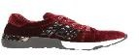 | TATA 321 708-8 | BURGUNDY | 87 | 6 | 13 | 18 | 21 | 16 | 9 | 4 | 55,95 € | 4.867,65 €
149052 | 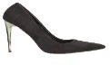 | TATA 334 2862-1/I17-S | BLACK | 90 | 1 | 1 | 6 | 29 | 26 | 23 | 4 | 49,95 € | 4.495,50 €
150998 |  | TATA 334 89547-9 | RED | 87 | 1 | 8 | 27 | 24 | 9 | 12 | 6 | 39,95 € | 3.475,65 €
150926 | 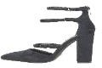 | TATA ITALIA 130 9354A-3 | D.BLUE | 83 | 8 | 8 | 12 | 23 | 14 | 12 | 6 | 49,95 € | 4.145,85 €
150924 | 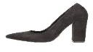 | TATA ITALIA 130 9354A-1 | BLACK | 81 | 6 | 10 | 12 | 23 | 9 | 15 | 6 | 45,95 € | 3.721,95 €
150905 | 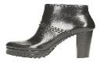 | TATA ITALIA 355 21528 X10-4 | BLACK | 79 | 2 | 1 | 6 | 18 | 19 | 25 | 8 | 69,95 € | 5.526,05 €
150654 | 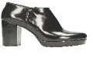 | TATA ITALIA 257 X21625-X21-3 | BLACK | 76 | 3 | 8 | 16 | 20 | 16 | 10 | 3 | 59,95 € | 4.556,20 €
150907 | 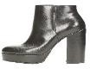 | TATA ITALIA 355 X21735A-X11 | BLACK | 74 | 1 | 3 | 16 | 23 | 11 | 17 | 3 | 69,95 € | 5.176,30 €
150251 | 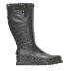 | TATA ITALIA 335 4511-  0320 | BLACK | 70 | 0 | 6 | 13 | 25 | 17 | 7 | 2 | 75,95 € | 5.316,50 €
149971 | 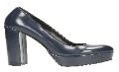 | TATA 48 LP90885-186 | BLUE | 69 | 2 | 7 | 16 | 21 | 9 | 9 | 5 | 55,95 € | 3.860,55 €
150266 | 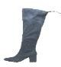 | TATA ITALIA 335 16075  0514 | GREY | 68 | 4 | 10 | 17 | 17 | 10 | 9 | 1 | 69,95 € | 4.756,60 €
150021 | 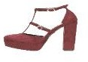 | TATA ITALIA 130 9379A-3 | RED | 64 | 0 | 5 | 10 | 21 | 16 | 10 | 2 | 49,95 € | 3.196,80 €
150029 | 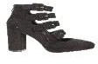 | TATA ITALIA 130 9400B-1 | BLACK | 64 | 0 | 8 | 13 | 21 | 8 | 9 | 5 | 59,95 € | 3.836,80 €
149048 | 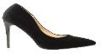 | TATA 334 95528-1 | BLACK | 59 | 0 | 5 | 7 | 15 | 11 | 21 | 0 | 49,95 € | 2.947,05 €
148686
149052
150998
149048
149971
149972
150921
150924
150926
150021
150029
150654
150266
150251
150905
150907
150650

ID SUPER | FOTO | ITEM | COL | Quantity total | 35 | 36 | 37 | 38 | 39 | 40 | 41 | RRP | Sum RRP
150996 | 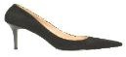 | TATA 334 89547-9 | BLACK | 57 | 1 | 7 | 14 | 13 | 9 | 10 | 3 | 39,95 € | 2.277,15 €
149076 |  | TATA 334 15036-1A | RED | 53 | 2 | 4 | 5 | 14 | 9 | 12 | 7 | 39,95 € | 2.117,35 €
150993 | 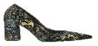 | TATA 334 6033-3 | BLACK | 53 | 6 | 9 | 12 | 17 | 3 | 3 | 3 | 39,95 € | 2.117,35 €
150666 | 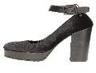 | TATA ITALIA 355 S21735-E03 | BLACK | 49 | 2 | 10 | 7 | 13 | 7 | 8 | 2 | 49,95 € | 2.447,55 €
145985 | 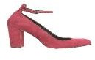 | TATA 48 LP90885-188 | WINE | 47 | 4 | 6 | 9 | 12 | 7 | 5 | 4 | 49,95 € | 2.347,65 €
150911 | 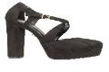 | TATA ITALIA 130 9379A-8 | BLACK | 46 | 0 | 1 | 4 | 15 | 9 | 15 | 2 | 49,95 € | 2.297,70 €
150997 | 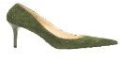 | TATA 334 89547-9 | GREEN | 44 | 1 | 4 | 14 | 10 | 7 | 6 | 2 | 39,95 € | 1.757,80 €
150015 | 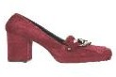 | TATA ITALIA 130 9380A-2 | BORDEAUX | 44 | 0 | 6 | 9 | 12 | 7 | 5 | 5 | 55,95 € | 2.461,80 €
150012 | 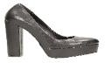 | TATA ITALIA 130 9379A-1 | BLACK | 42 | 2 | 5 | 2 | 20 | 6 | 6 | 1 | 49,95 € | 2.097,90 €
150989 | 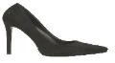 | TATA 334 1941-1A | BLACK | 39 | 1 | 1 | 0 | 9 | 9 | 18 | 1 | 49,95 € | 1.948,05 €
145393 | 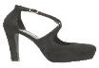 | TATA ITALIA 130 9221A-5 | BLACK | 39 | 1 | 4 | 2 | 6 | 14 | 8 | 4 | 49,95 € | 1.948,05 €
149066 | 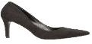 | TATA 334 15036-1 | BLACK | 37 | 1 | 5 | 5 | 16 | 4 | 4 | 2 | 39,95 € | 1.478,15 €
149986 | 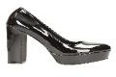 | TATA ITALIA 130 9403A-2-P | BLACK | 37 | 5 | 5 | 7 | 12 | 4 | 4 | 0 | 45,95 € | 1.700,15 €
150995 | 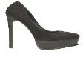 | TATA 334 2583-1 | BLACK | 36 | 4 | 2 | 2 | 9 | 4 | 10 | 5 | 49,95 € | 1.798,20 €
150912 | 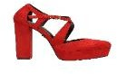 | TATA ITALIA 130 9379A-8 | RED | 36 | 0 | 4 | 3 | 14 | 4 | 9 | 2 | 49,95 € | 1.798,20 €
150014 | 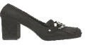 | TATA ITALIA 130 9380A-2 | BLACK | 36 | 1 | 5 | 10 | 15 | 1 | 4 | 0 | 55,95 € | 2.014,20 €
149106 | 149106 | TATA 334 9455-1 | BLACK | 35 | 0 | 0 | 8 | 11 | 4 | 7 | 5 | 49,95 € | 1.748,25 €
149066
149076
150989
150995
150993
150996
150997
145985
145393
150012
150911
150912
150014
150015
149986
150666

ID SUPER | FOTO | ITEM | COL | Quantity total | 35 | 36 | 37 | 38 | 39 | 40 | 41 | RRP | Sum RRP
145392 | 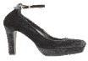 | TATA ITALIA 130 9221A-4 | BLACK | 35 | 0 | 2 | 3 | 10 | 7 | 8 | 5 | 49,95 € | 1.748,25 €
149109 | 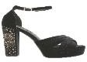 | TATA 334 A0821-5 | BLACK | 34 | 1 | 0 | 4 | 8 | 9 | 7 | 5 | 49,95 € | 1.698,30 €
150919 | 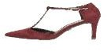 | TATA ITALIA 130 9207A-13/I17 | BORDEAUX | 34 | 3 | 4 | 6 | 3 | 6 | 7 | 5 | 39,95 € | 1.358,30 €
149054 | 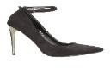 | TATA 334 2862-2 | BLACK | 33 | 0 | 0 | 7 | 15 | 2 | 4 | 5 | 49,95 € | 1.648,35 €
149050 | 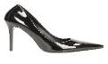 | TATA 334 98273-3 | BLACK | 33 | 0 | 2 | 8 | 7 | 6 | 7 | 3 | 49,95 € | 1.648,35 €
150923 | 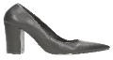 | TATA ITALIA 130 9354A-1 | BLACK | 33 | 4 | 1 | 7 | 11 | 6 | 3 | 1 | 45,95 € | 1.516,35 €
150992 |  | TATA 334 1941-1A | PINK | 32 | 3 | 3 | 8 | 5 | 4 | 7 | 2 | 49,95 € | 1.598,40 €
149081 | 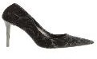 | TATA 334 3261-1 | BLACK | 29 | 0 | 3 | 3 | 6 | 6 | 11 | 0 | 49,95 € | 1.448,55 €
149105 | 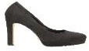 | TATA 334 9255-1 | BLACK | 29 | 1 | 1 | 1 | 14 | 2 | 9 | 1 | 49,95 € | 1.448,55 €
149046 | 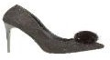 | TATA 334 95528-PF | BLACK | 29 | 1 | 3 | 5 | 6 | 0 | 10 | 4 | 49,95 € | 1.448,55 €
150991 |  | TATA 334 1941-1A | RED | 28 | 0 | 0 | 1 | 6 | 6 | 12 | 3 | 49,95 € | 1.398,60 €
149107 | 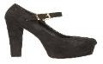 | TATA 334 20171-1 | BLACK | 27 | 1 | 0 | 0 | 14 | 3 | 3 | 6 | 49,95 € | 1.348,65 €
150025 | 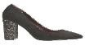 | TATA ITALIA 130 9383A-1 | BLACK | 27 | 3 | 4 | 5 | 6 | 4 | 3 | 2 | 35,95 € | 970,65 €
145377 | 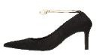 | TATA ITALIA 130 9206A-2A | BLACK | 26 | 0 | 2 | 2 | 12 | 6 | 3 | 1 | 49,95 € | 1.298,70 €
149937 | 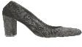 | TATA ITALIA 313 DS532-1 | BLACK | 26 | 5 | 6 | 4 | 1 | 2 | 4 | 4 | 39,95 € | 1.038,70 €
149074 |  | TATA 334 15036-1 | RED | 25 | 1 | 4 | 3 | 10 | 2 | 4 | 1 | 39,95 € | 998,75 €
150020 | 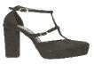 | TATA ITALIA 130 9379A-3 | BLACK | 24 | 0 | 0 | 1 | 8 | 7 | 4 | 4 | 49,95 € | 1.198,80 €
149074
150992
150991
149107
149054
149081
149105
149046
149050
149109
145377
150919
145392
150923
150020
150025
149937

ID SUPER | FOTO | ITEM | COL | Quantity total | 35 | 36 | 37 | 38 | 39 | 40 | 41 | RRP | Sum RRP
150007 | 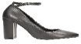 | TATA ITALIA 130 9383A-4 | BLACK | 24 | 1 | 1 | 9 | 6 | 2 | 1 | 4 | 39,95 € | 958,80 €
150027 | 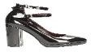 | TATA ITALIA 130 9400A-2 | BLACK | 24 | 0 | 5 | 2 | 7 | 4 | 3 | 3 | 49,95 € | 1.198,80 €
145389 | 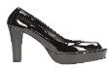 | TATA ITALIA 130 9221A-3 | BLACK | 23 | 1 | 4 | 0 | 7 | 7 | 3 | 1 | 49,95 € | 1.148,85 €
150909 | 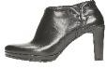 | TATA ITALIA 355 21641 X08-3 | BLACK | 23 | 0 | 1 | 2 | 8 | 3 | 8 | 1 | 69,95 € | 1.608,85 €
150994 | 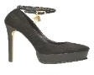 | TATA 334 2583-3 | BLACK | 22 | 5 | 2 | 4 | 2 | 2 | 5 | 2 | 49,95 € | 1.098,90 €
145383 | 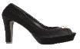 | TATA ITALIA 130 9221A-3A | BLACK | 22 | 2 | 1 | 2 | 8 | 2 | 5 | 2 | 49,95 € | 1.098,90 €
149051 |  | TATA 334 2562-1 | BLACK | 21 | 0 | 3 | 0 | 4 | 5 | 8 | 1 | 49,95 € | 1.048,95 €
149984 | 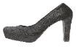 | TATA ITALIA 130 9221A-1/I17 | BLACK | 20 | 0 | 2 | 2 | 6 | 5 | 2 | 3 | 45,95 € | 919,00 €
149064 | 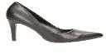 | TATA 334 15036-1B | BLACK | 19 | 1 | 1 | 1 | 1 | 4 | 10 | 1 | 39,95 € | 759,05 €
150045 | 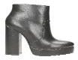 | TATA ITALIA 130 9394B-1 | BLACK | 18 | 2 | 0 | 2 | 6 | 5 | 3 | 0 | 59,95 € | 1.079,10 €
149075 | 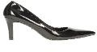 | TATA 334 15036-1A | BLACK | 17 | 0 | 1 | 1 | 10 | 1 | 4 | 0 | 39,95 € | 679,15 €
149053 | 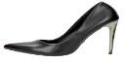 | TATA 334 2862-1/I17 | BLACK | 16 | 0 | 2 | 2 | 0 | 5 | 3 | 4 | 49,95 € | 799,20 €
149973 | 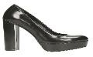 | TATA 48 LP90885-186 | BLACK | 16 | 0 | 2 | 2 | 6 | 4 | 2 | 0 | 55,95 € | 895,20 €
149998 | 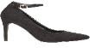 | TATA ITALIA 130 9205A-33 | BLACK | 15 | 0 | 3 | 0 | 5 | 2 | 5 | 0 | 39,95 € | 599,25 €
150918 | 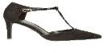 | TATA ITALIA 130 9207A-13/I17 | BLACK | 15 | 0 | 1 | 1 | 3 | 2 | 7 | 1 | 39,95 € | 599,25 €
137957 | 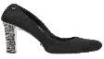 | TATA ITALIA 257 LOTO- 0059 | BLACK | 14 | 0 | 0 | 7 | 6 | 1 | 0 | 0 | 55,95 € | 783,30 €
146165 | 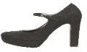 | TATA 48 LP1251803-9 | BLACK | 14 | 0 | 0 | 0 | 3 | 1 | 6 | 4 | 49,95 € | 699,30 €
137957
149075
149064
149051
150994
149053
146165
149973
149998
150918
149984
145389
145383
150007
150045
150027
150909

ID SUPER | FOTO | ITEM | COL | Quantity total | 35 | 36 | 37 | 38 | 39 | 40 | 41 | RRP | Sum RRP
150916 | 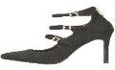 | TATA ITALIA 130 9206A-12 | BLACK | 14 | 2 | 1 | 0 | 1 | 3 | 4 | 3 | 39,95 € | 559,30 €
149989 | 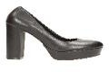 | TATA ITALIA 130 9403A-2 | BLACK | 14 | 0 | 3 | 3 | 2 | 3 | 2 | 1 | 45,95 € | 643,30 €
150668 | 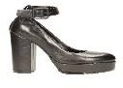 | TATA ITALIA 355 S21735-E03-P | BLACK | 14 | 0 | 1 | 2 | 2 | 3 | 3 | 3 | 49,95 € | 699,30 €
149070 | 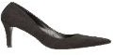 | TATA 334 15036-1 | BLUE | 13 | 0 | 1 | 2 | 6 | 1 | 2 | 1 | 39,95 € | 519,35 €
150917 | 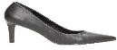 | TATA ITALIA 130 9207A-1 | BLACK | 13 | 1 | 1 | 1 | 5 | 0 | 4 | 1 | 39,95 € | 519,35 €
145938 | 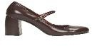 | TATA 48 LP851688-2 | WINE | 12 | 0 | 1 | 0 | 4 | 1 | 5 | 1 | 49,95 € | 599,40 €
138975 |  | TATA ITALIA 130 9042C-9 | RED | 11 | 0 | 0 | 0 | 2 | 5 | 3 | 1 | 49,95 € | 549,45 €
145937 | 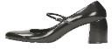 | TATA 48 LP851688-2 | BLACK | 11 | 2 | 2 | 4 | 1 | 1 | 1 | 0 | 49,95 € | 549,45 €
149985 | 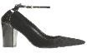 | TATA ITALIA 130 9354A-4 | BLACK | 11 | 1 | 0 | 0 | 3 | 0 | 5 | 2 | 49,95 € | 549,45 €
145450 | 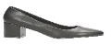 | TATA ITALIA 130 9361A-1-P | BLACK | 11 | 2 | 3 | 1 | 2 | 0 | 2 | 1 | 39,95 € | 439,45 €
150990 | 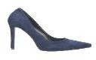 | TATA 334 1941-1A | NAVY | 10 | 1 | 1 | 1 | 1 | 0 | 6 | 0 | 49,95 € | 499,50 €
151005 |  | TATA ITALIA 130 9361A-1 | RED | 10 | 2 | 1 | 6 | 1 | 0 | 0 | 0 | 39,95 € | 399,50 €
150913 | 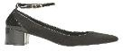 | TATA ITALIA 130 9361A-2 | BLACK | 9 | 0 | 2 | 7 | 0 | 0 | 0 | 0 | 39,95 € | 359,55 €
146163 | 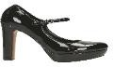 | TATA 48 LP1251803-9- P | BLACK | 8 | 0 | 0 | 0 | 5 | 0 | 3 | 0 | 49,95 € | 399,60 €
145984 | 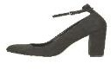 | TATA 48 LP90885-188 | BLACK | 8 | 1 | 1 | 0 | 0 | 2 | 4 | 0 | 49,95 € | 399,60 €
149055 | 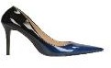 | TATA 334 98273-3C | NAVY | 7 | 0 | 0 | 1 | 1 | 2 | 2 | 1 | 49,95 € | 349,65 €
149077 | 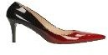 | TATA 334 B581-1 | RED | 7 | 0 | 0 | 2 | 3 | 0 | 0 | 0 | 35,95 € | 251,65 €
138975
149070
150990
149055
149077
146163
145937
145938
145984
150916
150917
149985
151005
145450
150913
149989
150668

ID SUPER | FOTO | ITEM | COL | Quantity total | 35 | 36 | 37 | 38 | 39 | 40 | 41 | RRP | Sum RRP
150914 | 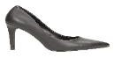 | TATA ITALIA 130 9205A-1/17 | BLACK | 7 | 0 | 1 | 0 | 2 | 1 | 2 | 1 | 39,95 € | 279,65 €
150023 | 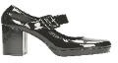 | TATA ITALIA 130 9380A-1 | BLACK-1 | 7 | 0 | 1 | 2 | 1 | 1 | 0 | 2 | 49,95 € | 349,65 €
149063 |  | TATA 334 98273-3D | NUDE | 6 | 0 | 0 | 0 | 2 | 0 | 3 | 1 | 49,95 € | 299,70 €
150920 | 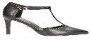 | TATA ITALIA 130 9207A-13-P/I17 | BLACK | 6 | 0 | 1 | 1 | 0 | 1 | 2 | 1 | 39,95 € | 239,70 €
150925 | 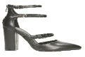 | TATA ITALIA 130 9354A-3 | BLACK | 6 | 0 | 0 | 1 | 1 | 0 | 1 | 3 | 49,95 € | 299,70 €
150084 | 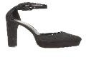 | TATA ITALIA 162 C228G-14 | BLACK | 6 | 0 | 0 | 0 | 3 | 0 | 2 | 1 | 49,95 € | 299,70 €
150658 | 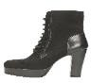 | TATA ITALIA 355 X21737A-E02-6 | BLACK | 6 | 1 | 0 | 0 | 1 | 2 | 2 | 0 | 59,95 € | 359,70 €
145449 | 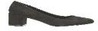 | TATA ITALIA 130 9361A-1 | BLACK | 5 | 0 | 2 | 1 | 1 | 1 | 0 | 0 | 39,95 € | 199,75 €
149990 | 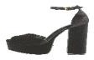 | TATA ITALIA 130 9415L 3 | BLACK | 5 | 0 | 0 | 1 | 0 | 4 | 0 | 0 | 49,95 € | 249,75 €
150088 | 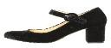 | TATA ITALIA 162 C404B-23 | BLACK | 5 | 0 | 0 | 2 | 2 | 0 | 0 | 1 | 45,95 € | 229,75 €
150922 | 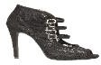 | TATA ITALIA 130 9116B-1 | BLACK | 4 | 0 | 1 | 0 | 2 | 1 | 0 | 0 | 49,95 € | 199,80 €
149981 | 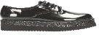 | TATA ITALIA 130 9378C-4 | BLACK | 4 | 0 | 0 | 0 | 0 | 3 | 0 | 1 | 55,95 € | 223,80 €
138977 | 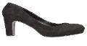 | TATA ITALIA 130 9220A-1-M | BLACK | 3 | 2 | 0 | 1 | 0 | 0 | 0 | 0 | 39,95 € | 119,85 €
135334 |  | TATA ITALIA 130 9221A-2 | 0 | 3 | 0 | 0 | 0 | 1 | 1 | 1 | 0 | 49,95 € | 149,85 €
149110 | 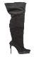 | TATA 334 G2583-26 | BLACK | 3 | 0 | 0 | 1 | 1 | 1 | 0 | 0 | 65,95 € | 197,85 €
145965 | 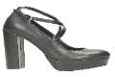 | TATA 48 LP90885-187 | BLACK | 3 | 0 | 0 | 0 | 0 | 0 | 3 | 0 | 59,95 € | 179,85 €
145963 | 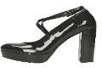 | TATA 48 LP90885-187- P | BLACK | 3 | 0 | 0 | 0 | 1 | 0 | 2 | 0 | 59,95 € | 179,85 €
138977
135334
149063
149110
145965
145963
150922
150914
150920
150925
145449
149981
150023
149990
150084
150088
150658

ID SUPER | FOTO | ITEM | COL | Quantity total | 35 | 36 | 37 | 38 | 39 | 40 | 41 | RRP | Sum RRP
150024 | 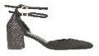 | TATA ITALIA 130 9365A-5 | BLACK | 3 | 0 | 1 | 2 | 0 | 0 | 0 | 0 | 45,95 € | 137,85 €
151289 | 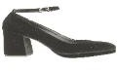 | TATA ITALIA 194 2225D-22 | BLACK | 3 | 0 | 0 | 2 | 1 | 0 | 0 | 0 | 39,95 € | 119,85 €
137803 | 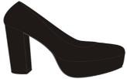 | TATA ITALIA 130 9042A-1/I16 | BLACK | 2 | 0 | 0 | 0 | 0 | 1 | 1 | 0 | 49,95 € | 99,90 €
149056 |  | TATA 334 98273-3C | RED | 2 | 0 | 0 | 0 | 0 | 0 | 1 | 1 | 49,95 € | 99,90 €
150915 | 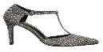 | TATA ITALIA 130 9205A-8/I17 | GUN METAL | 2 | 1 | 0 | 0 | 0 | 0 | 0 | 1 | 39,95 € | 79,90 €
150016 | 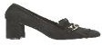 | TATA ITALIA 130 9365A-8 | BLACK | 2 | 0 | 1 | 0 | 0 | 0 | 0 | 1 | 45,95 € | 91,90 €
149996 | 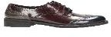 | TATA ITALIA 130 9391C-2 | BLACK | 2 | 1 | 0 | 0 | 0 | 0 | 1 | 0 | 49,95 € | 99,90 €
149991 |  | TATA ITALIA 130 9415L 3 | BORDEAUX | 2 | 0 | 0 | 0 | 0 | 1 | 1 | 0 | 49,95 € | 99,90 €
150655 | 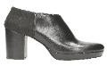 | TATA ITALIA 257 X21625-X21-3-P | BLACK | 2 | 0 | 0 | 0 | 0 | 2 | 0 | 0 | 59,95 € | 119,90 €
129044 | 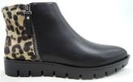 | TATA ITALIA 130 9087B-3 | BLACK | 1 | 0 | 1 | 0 | 0 | 0 | 0 | 0 | 55,95 € | 55,95 €
126940 |  | TATA ITALIA 130 9095A-1 | BLACK | 1 | 0 | 0 | 0 | 0 | 1 | 0 | 0 | 49,95 € | 49,95 €
135356 | 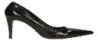 | TATA ITALIA 130 9208A-1 | BLACK | 1 | 0 | 1 | 0 | 0 | 0 | 0 | 0 | 39,95 € | 39,95 €
138979 | 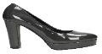 | TATA ITALIA 130 9225A-1 | DK GREY | 1 | 0 | 0 | 0 | 1 | 0 | 0 | 0 | 39,95 € | 39,95 €
138978 | 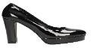 | TATA ITALIA 130 9225A-1-PP | BLACK | 1 | 1 | 0 | 0 | 0 | 0 | 0 | 0 | 39,95 € | 39,95 €
137988 | 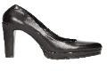 | TATA ITALIA 257 21639 X01-3 | BLACK | 1 | 0 | 0 | 0 | 0 | 1 | 0 | 0 | 55,95 € | 55,95 €
137958 | 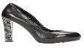 | TATA ITALIA 257 LOTO- 0059-P | BLACK | 1 | 1 | 0 | 0 | 0 | 0 | 0 | 0 | 55,95 € | 55,95 €
143503 |  | TATA 334 988 | BLUE | 1 | 0 | 0 | 1 | 0 | 0 | 0 | 0 | 39,95 € | 39,95 €
129044
126940
137803
135356
138979
138978
137988
137958
143503
149056
150915
150024
150016
149996
149991
151289
150655

ID SUPER | FOTO | ITEM | COL | Quantity total | 35 | 36 | 37 | 38 | 39 | 40 | 41 | RRP | Sum RRP
148687 | 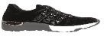 | TATA 321 708-8 | BLACK | 1 | 1 | 0 | 0 | 0 | 0 | 0 | 0 | 55,95 € | 55,95 €
146168 | 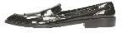 | TATA 48 LP351443-3 | BLACK | 1 | 0 | 1 | 0 | 0 | 0 | 0 | 0 | 59,95 € | 59,95 €
150044 | 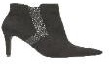 | TATA ITALIA 130 9205B-18 | BLACK | 1 | 0 | 1 | 0 | 0 | 0 | 0 | 0 | 55,95 € | 55,95 €
149978 | 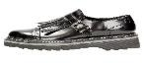 | TATA ITALIA 130 9390C-2 | BLACK | 1 | 0 | 0 | 0 | 0 | 0 | 1 | 0 | 55,95 € | 55,95 €
149995 | 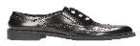 | TATA ITALIA 130 9391C-1 | BLACK | 1 | 0 | 0 | 0 | 0 | 1 | 0 | 0 | 49,95 € | 49,95 €
149997 | 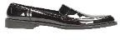 | TATA ITALIA 130 9391C-5 | BLACK | 1 | 0 | 1 | 0 | 0 | 0 | 0 | 0 | 45,95 € | 45,95 €
150090 | 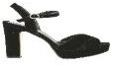 | TATA ITALIA 162 S416D-24 | BLACK | 1 | 0 | 0 | 0 | 0 | 0 | 1 | 0 | 49,95 € | 49,95 €
150649 | 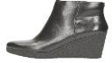 | TATA ITALIA 257 X21739-X07-5 | BLACK | 1 | 0 | 0 | 0 | 0 | 0 | 0 | 1 | 59,95 € | 59,95 €
149929 |  | TATA ITALIA 313 DW526-31 | BLACK | 1 | 0 | 1 | 0 | 0 | 0 | 0 | 0 | 55,95 € | 55,95 €
151150 | 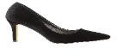 | TATA ITALIA 351 73A329-1 | BLACK | 1 | 0 | 0 | 1 | 0 | 0 | 0 | 0 | 35,95 € | 35,95 €
150659 | 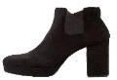 | TATA ITALIA 355 X21737A-E05-4 | BLACK | 1 | 1 | 0 | 0 | 0 | 0 | 0 | 0 | 59,95 € | 59,95 €
151182 | 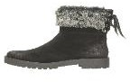 | TATA ITALIA 80 45PHT09 | BLACK | 1 | 0 | 0 | 0 | 1 | 0 | 0 | 0 | 59,95 € | 59,95 €
151179 | 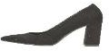 | TATA ITALIA 80 95EG01 | BLACK | 1 | 0 | 0 | 1 | 0 | 0 | 0 | 0 | 45,95 € | 45,95 €
151178 | 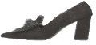 | TATA ITALIA 80 95EG03 | BLACK | 1 | 0 | 0 | 0 | 0 | 0 | 0 | 1 | 49,95 € | 49,95 €
155747 | 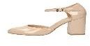 | TATA 368 9498A-1 | BEIGE | 1 | 0 | 0 | 0 | 0 | 0 | 1 | 0 | 39,95 € | 39,95 €
162303 | 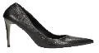 | TATA 334 2862-1/I18 | BLACK | 1 | 0 | 1 | 0 | 0 | 0 | 0 | 0 | 49,95 € | 49,95 €
162884 |  | TATA ITALIA 371 387106-04A | BLACK | 1 | 0 | 0 | 0 | 0 | 0 | 1 | 0 | 69,95 € | 69,95 €
148687
146168
150044
149978
149995
149997
150090
150649
149929
151150
150659
151182
151179
151178
155747
162303
162884

172167
ID SUPER | FOTO | ITEM | COL | Quantity total | 35 | 36 | 37 | 38 | 39 | 40 | 41 | RRP | Sum RRP
172167 | 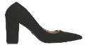 | TATA 393 DW701A- 16/I19 | BLACK | 1 | 0 | 0 | 0 | 1 | 0 | 0 | 0 | 39,95 € | 39,95 €
Quantity total |  |  |  | 5.279 |  |  |  |  |  |  |  | 51,20 € | 270.294,05 €

